

**Sample Music Assessment**

 

**Student Booklet**

**Proctor Booklet**

**Scoring Rubrics**

**Spring 2014**

 

**NOTE FROM ARTS ACHIEVE**

This performance assessment was developed by staff from the Weil Music Institute at Carnegie Hall in conjunction with the New York City Department of Education’s Director of Music. This packet contains the student assessment booklet, proctor booklet, and rubrics used to score each task.

The Arts Achieve assessments were developed for the specific purpose of measuring students’ overall achievement as a class. Results will reveal gaps in student learning and provide insight into how students can progress toward recognized standards. In this way, the assessment results can also be used to measure teacher effectiveness. It is NOT the intention for this assessment to be used to grade individual students.

The Music assessments are crafted around the Core Music curriculum rather than skills acquisition on an instrument or vocal technique. Some of the artistic tasks, such as composition, are also written tasks. The assessments use imaginative settings to engage students in listening, analyzing, composing and transcribing music. Selections from diverse musical genres prompt the student responses. The Music assessments contain the following tasks:

**Discipline-Based Performance Tasks**

* Compose
* Perform (a previously learned piece, or the phrase composed earlier in the assessment)

**Written Performance Tasks**

* Demonstrate recognition of elements and vocabulary of musical notation, such as tempo, clef, bar, time signature, note names, note values, and pitch relationships.
* Compose and notate a rhythmic or musical phrase.
* Identify, compare and contrast instrumentation, dynamics, mood, tempi and major/minor key in pieces of music.
* Match notation to music.
* Express and justify musical preferences and choices.
* Describe roles in music (performer, listener, composer, critic, arranger).
* Write about music with a particular purpose in mind (e.g., write a music review).

For the high school assessment, Task 3, we wanted 3 examples in which the tonality was very clearly either minor or major. We wanted to find recordings from a variety of styles and historical periods. We obtained the rights to use a recordings of J.S. Bach’s *2-Part Invention No. 1*, *Summertime* performed by Ella Fitzgerald, and *Tu Voz* performed by Marta Gomez.

For Task 4, we wanted to find 2 recordings that had some similarities and some differences. It was important to find recordings from ensembles with different instrumentation (one vocal and one instrumental), and it was helpful to have the music be from different cultural traditions. We obtained the rights to use recordings of *Shenandoah* performed by Thomas Hampson and *Sun Out* performed by Eric Reed. We are unable to provide these recordings ourselves, but these pieces or comparable works can be found using other resources.

While all of the Arts Achieve performance assessments are psychometrically validated and developed against recognized standards, instructors are encouraged to re-interpret and modify tasks to fit their own classes’ needs. We hope this assessment will be useful to your practice and your students!

**High School Music Assessment**

**TASK 1: SCORE STUDY**

Study the score below and then answer the questions that follow.

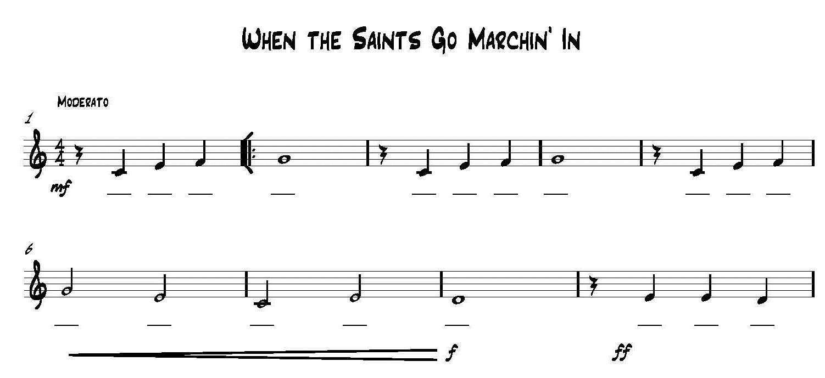

1. What is the Time Signature for this piece? ________________________________
2. What is the tempo for this piece? _______________________________________
3. What is the Key Signature for this piece? ______________________________
4. In what measure (number) does the crescendo begin?________________________________
5. Name each of the notes, using the blank lines below the staff.

**TASK 2: NOTATION, RHYTHM AND METER**

Create 8 measures of rhythm on the lines below. Use at least 1 of each of the notes provided below. Use at least 1 of each of the rests provided below. Remember to use each note and rest and be aware of the time signature. **Do not repeat measures.**

 



**TASK 3: MAJOR OR MINOR?**

Listen to each of the following three excerpts. Indicate whether the excerpt is in a Major or a Minor key by circling the correct answer. You will hear each excerpt three times.

Excerpt 1: Major Minor

Excerpt 2: Major Minor

Excerpt 2: Major Minor

**TASK 4: PERFORMANCE REVIEWS**

In Task 4, you will listen to two musical excerpts and write your responses in the spaces provided on the next page.

PERFORMANCES TO REVIEW:

• Thomas Hampson “Shenandoah”

• Eric Reed “Sun Out”

*As you review each of the performances, refer to these musical terms:*

|  |
| --- |
| **Mood Meter Tempo Melody Dynamics** |

|  |  |  |
| --- | --- | --- |
| **Questions** | **Selection 1: “Shenandoah”**  **Performer: Thomas Hampson** | **Selection 2: “Sun Out”**  **Performer: Eric Reed** |
| **4 A/B. What voice type(s) or instrument(s) do you hear?** | 4A. | 4B. |
| **4 C/D. Describe the tempo of this piece using standard Italian musical vocabulary.** | 4C. | 4D. |
| **4 E/F. Describe the dynamics used in this piece using standard Italian musical vocabulary.** | 4E. | 4F. |
| **4 G/H. Describe the mood of this piece? How do the composer and/or performer(s) create this mood?** | 4G. | 4H. |

**TASK 5: COMPARE/CONTRAST**

Now that you have heard both performances, use the boxes below to describe the similarities and differences you noticed. **Use complete sentences, music vocabulary, and details in your response.**

* Thomas Hampson ‘Shenandoah’
* Eric Reed ‘Sun Out’

|  |
| --- |
| **Task 5A: Identify and describe 2 similarities between ‘Shenandoah’ and ‘Sun Out’** |
| (For Example: Shenandoah is ______________ **AND** Sun Out is __________.) |
| **Task 5B: Identify and describe 2 differences between ‘Shenandoah and ‘Sun Out’** |
| (For Example: Shenandoah is ______________ **BUT** Sun Out is __________.) |

**TASK 6: PERFORMANCE**

For this task, you will learn and perform Voice 1 from the chant below. Listen to your proctor as he/she teaches you the chant.

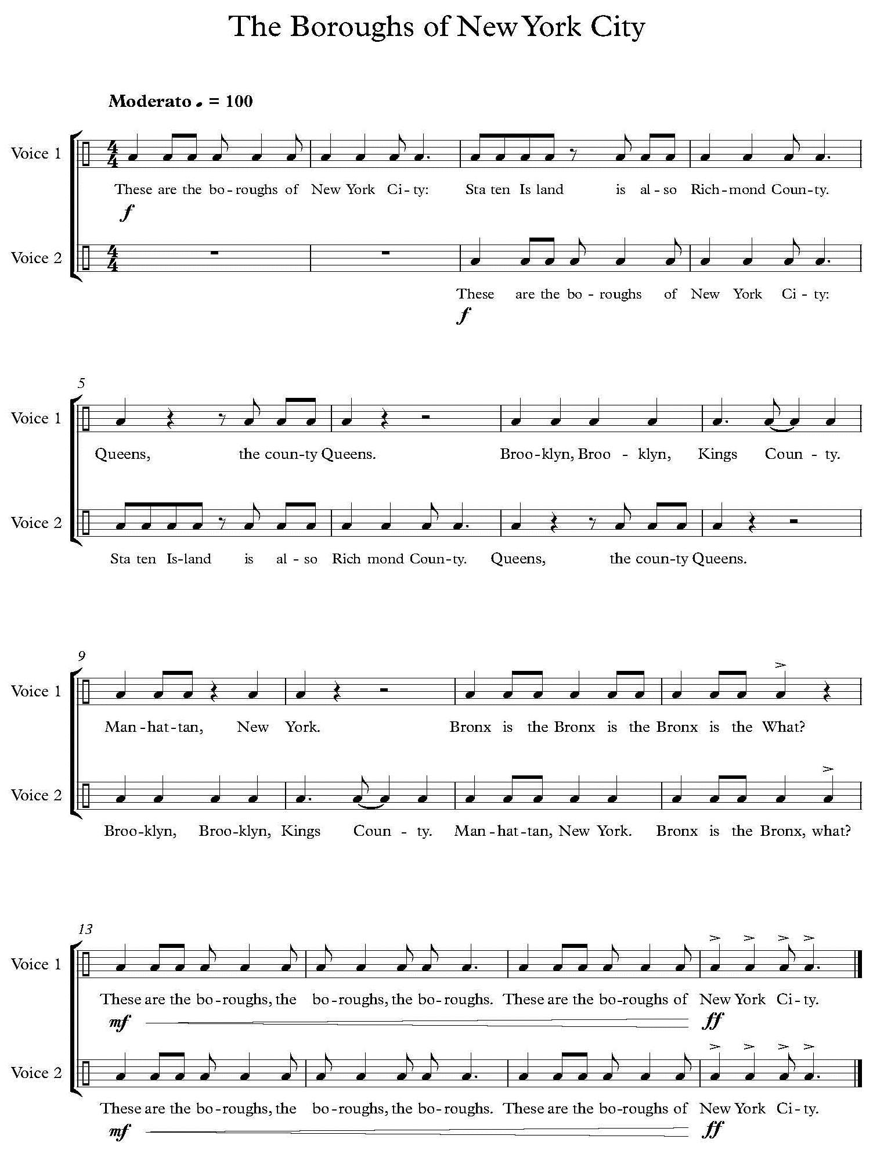

**TASK 7:** **WRITING A REVIEW**

Write a brief review of one of the two pieces of music you heard. How effectively does this piece convey mood? Which elements of the piece are executed effectively and which elements could be improved? Support your review using the notes you took and the music vocabulary you used for Task 5. The review should be 2 – 3 paragraphs in length. Be sure to write complete sentences.

________________________________________________________________________________

________________________________________________________________________________

________________________________________________________________________________

________________________________________________________________________________

________________________________________________________________________________

________________________________________________________________________________

________________________________________________________________________________

________________________________________________________________________________

________________________________________________________________________________

________________________________________________________________________________

________________________________________________________________________________

________________________________________________________________________________

________________________________________________________________________________

________________________________________________________________________________

________________________________________________________________________________

________________________________________________________________________________

________________________________________________________________________________

________________________________________________________________________________

________________________________________________________________________________

________________________________________________________________________________



**Arts Achieve Assessment:**

**MUSIC**

**PROCTOR Booklet—High School**

**Spring 2014**

What you need to administer the NYC Department of Education Music Assessment:

* Proctor Booklet, which contains scripting for proctor to read
* Audio CD provided by the NYC Department of Education
* Audio Player such as a computer with CD playback or a CD player
* Student Exam Booklets

What you need to give the NYC Department of Education Music Assessment:

* Proctor Booklet, which contains scripting for proctor to read
* Audio CD provided by the NYC Department of Education
* Audio Player such as a computer with CD playback or a CD player
* Student Exam Booklets
* Sticky notes for each student
* Grading Booklet

**Please note that there are prompts for proctors to read aloud to students written in red. Speak slowly and clearly when reading these directives. Remind students to read and re-read the directions for all tasks. Student pages are located in blue boxes in the proctor booklet.**

**Please note that there are prompts for proctors to read aloud to students written in red. Speak slowly and clearly when reading these directions. Remind students to read and re-read the directions for all tasks. Student pages are located in blue boxes in the proctor booklet.**

What you need to give the NYC Department of Education Music Assessment:

* Proctor Booklet, which contains scripting for proctor to read
* Audio CD provided by the NYC Department of Education
* Audio Player such as a computer with CD playback or a CD player
* Student Exam Booklets
* Sticky notes for each student
* Grading Booklet

**Please note that there are prompts for proctors to read aloud to students written in red. Speak slowly and clearly when reading these directives. Remind students to read and re-read the directions for all tasks. Student pages are located in blue boxes in the proctor booklet.**

**High School Music Assessment**

***Proctor: “Please turn to page #1. (Read the following aloud):***

**TASK 1: SCORE STUDY**

**Study the score below and then answer the questions that follow.**



1. What is the Time Signature for this piece? ______________________
2. What is the tempo for this piece? _________________________
3. What is the Key Signature for this piece? ______________________
4. In what measure (number) does the crescendo begin? _____________________
5. Name each of the notes, using the blank lines below the staff.

**TASK 2: NOTATION, RHYTHM AND METER**

**In Task 2, you will create 8 measures of rhythm on the lines below. Use at least 1 of each of the notes provided below. Use at least 1 of each of the rests provided below. Remember to use each note and rest and be aware of the time signature. Do not repeat measures.**

 



**“You will have 15 minutes to complete Tasks 1-2. Please begin.”**

**After 15 minutes, announce: “Your time is now up. Please look at Task 3 as I read the directions aloud.”**

**TASK 3: MAJOR OR MINOR?**

**“Listen to the following three excerpts. Indicate whether the excerpt is in a Major or a Minor key by circling the correct answer. You will hear each excerpt three times.”**

Excerpt 1: Major Minor

Excerpt 2: Major Minor

Excerpt 3: Major Minor

**Here is “Selection #1”: (Play Track #1: “2-Part Invention No. 1”)**

**Wait 30 seconds**

**Here is “Selection # 1, again.” (Play Track #1 a second time)**

**Wait 30 seconds**

**Here is “Selection # 1, final time.” Play Track #1 a third time.**

**Wait 30 seconds before moving on**

**Repeat Instructions for Selections # 2 and # 3 (Track #2“Summertime” and Track #3 “Tu Voz”)**

**“You will now be asked to respond to two pieces of music. Please look at the directions for Task 4 as I read them aloud.”**

**TASK 4: PERFORMANCE REVIEWS**

**In Task 4, you will listen to two musical excerpts and write your responses in the spaces provided on the next page.**

**PERFORMANCES TO REVIEW:**

• Thomas Hampson “Shenandoah”

• Eric Reed “Sun Out”

*As you review each of the performances, refer to these musical terms:*

|  |
| --- |
| **Mood Meter Tempo Melody Dynamics** |

**“Each selection will be played three times. The questions appear in the column on the left. Write your answers in the columns provided on the right. There is one column for each excerpt. Remember to be as descriptive as possible in your responses and use musical terminology. You will need these descriptions to complete a later task. Please take a moment to look at the questions on the next page as I read them aloud.”**

**Read Task 4 questions aloud.**

**“I will now play the selections for you.”**

**“Selection #1: “Shenandoah” performed by Thomas Hampson:**

**(Play Track #4: “Shenandoah”)**

**Wait 2 minutes**

**“Selection #1: “Shenandoah” performed by Thomas Hampson:**

**(Play Track #4: “Shenandoah” a second time)**

**Wait 2-3 minutes.**

**Say “Selection #1: “Shenandoah” performed by Thomas Hampson,, final time:**

**Play Track #4 a third time.**

**Wait 2-3 minutes before moving on. Repeat Instructions for Selections #2 : Track #5 ‘Sun Out’ by Eric Reed.**

**“Take a moment to finish writing before we move on to Task 5”  
Wait 2 minutes**

**“*Please Turn to Task 5”***

**Use complete sentences and music vocabulary in your responses.**

|  |  |  |
| --- | --- | --- |
| **Questions** | **Selection 1: “Shenandoah”**  **Performer: Thomas Hampson** | **Selection 2: “Sun Out”**  **Performer: Eric Reed** |
| **4 A/B. What voice type(s) or instrument(s) do you hear?** | 4A. | 4B. |
| **4 C/D. Describe the tempo of this piece using standard Italian musical vocabulary.** | 4C. | 4D. |
| **4 E/F. Describe the dynamics used in this piece using standard Italian musical vocabulary.** | 4E. | 4F. |
| **4 G/H. Describe the mood of this piece? How do the composer and/or performer(s) create this mood?** | 4G. | 4H. |

**TASK 5: COMPARE/CONTRAST**

Now that you have heard both performances, use the boxes below to describe the similarities and differences you noticed. **Use complete sentences, music vocabulary, and details in your response.**

* Thomas Hampson ‘Shenandoah’
* Eric Reed ‘Sun Out’

|  |
| --- |
| **Task 5A: Identify and describe 2 similarities between ‘Shenandoah’ and ‘Sun Out’** |
| (For Example: Shenandoah is ______________ **AND** Sun Out is __________.) |
| **Task 5B: Identify and describe 2 differences between ‘Shenandoah’ and ‘Sun Out’** |
| (For Example: Shenandoah is ______________ **BUT** Sun Out is __________.) |

**TASK 6: PERFORMANCE**

**For this task, you will learn and perform Voice 1 from chant below. Listen to your proctor as he/she teach you the chant.**



* To complete this task, we will learn the chant in Voice 1 by listening to it and reading the notation . You will be given time to practice the chant’s rhythm.
* To conclude this task, I will ask groups of 4 to perform Voice 1 of the chant for me. You will perform along with a recording that includes Voice 2 of the chant. You will be expected to chant Voice 1 steadily throughout your performance.

Let us begin.

1. First, we’ll listen to Voice 1from the chant.

* Follow your sheet music. You may write notes or otherwise mark up your score.
* You may chant along and/or tap feet/clap to keep the beat.

PLAY CD TRACK # 6 “The Boroughs of New York City” VOICE 1  
AGAIN, PLAY CD TRACK # 6

1. We will now learn Voice 1 together

* Take a look at Voice 1 on your sheet music.
* You may write on your score at any time.
* Chant Voice 1 with me as I play “The Boroughs of New York City” Voice 1 on the CD.

PLAY CD TRACK # 6 “The Boroughs of New York City” VOICE 1  
AGAIN, PLAY CD TRACK # 6

* Take one minute to make notes.

1. Now I will provide you with time to practice the rhythms. I will play Voice 1 two times, during which you may practice the Voice 1 chant.

PLAY CD TRACK # 6 “The Boroughs of New York City” VOICE 1 two times and let students practice their rhythms.

1. Now, I will play Voice 2 and have you practice Voice 1 along with the recording of Voice 2.
2. PLAY CD TRACK # 7 “The Boroughs of New York City” VOICE 2
3. At this time I will be calling students up in groups of 4 to perform. I will ask all of you to perform Voice 1 of the chant for me while I play a recording of Voice 2. Remember, you are only to chant Voice 1, despite the fact that Voice 2 will be playing.
4. When you are not performing, please practice Voice 1 of the chant silently, listen to your classmates perform, or continue on to Task 7: Writing a Review.

Call up students in groups of four to perform until all students have performed the chant.

PLAY CD TRACK #7 ““The Boroughs of New York City” VOICE 2 as each group performs.

**TASK #7:** **WRITING A REVIEW**

**Write a brief review of one of the two pieces of music you heard. How effectively does this piece convey mood? Which elements of the piece are executed effectively and which elements could be improved? Support your review using the notes you took and the music vocabulary you used for Task 5. The review should be 2 – 3 paragraphs in length. Be sure to write complete sentences.**

**END of assessment**

**1**

**12th GRADE MUSIC RUBRIC – Spring 2014**

|  |  |  |  |  |
| --- | --- | --- | --- | --- |
|  | **4 YES** | **3 YES BUT** | **2 NO BUT** | **1 NO** |
| **1A. What is the time signature of this piece?** | 4/4 |  |  | Anything other than 4/4 |
| **1B. What is the tempo of this piece?** | **Moderato** |  |  | Anything other than  **Moderato**. |
| **1C. What key signature is this piece written in?** | C Major |  |  | Anything other than  ‘C Major’ |
| **1D. What measure does the crescendo start in?** | ‘mm. 6’ or just ‘6’ |  |  | Anything other than  ‘mm. 6’ or just ‘6’ |
| **1E. Note Identification** Answer:  C E F G C E F G  C E F G E C E D E E D | All 19 notes were correctly labeled. | 14 to 18 notes were labeled correctly | 7 to 13 notes were labeled correctly | 6 or fewer notes were correctly labeled. |
| **TASK 2:** Composition | Completes a unique 8-measure rhythm correctly (adhering to the 4/4 time signature). None of the measures are repeated. | Completes at least 6 unique measures of rhythm correctly (adhering to the 4/4 time signature), but two of the measures are incorrect, incomplete, or are repeated. | Completes 5 or less unique measures of rhythm correctly (adhering to the 4/4 time signature). The other measures are incomplete, incorrect, or are repeated. | Attempts to complete the task, but no measures adhere to the 4/4 time signature. |
| **TASK 3: MAJOR/MINOR right or wrong answers** *Major, Minor, Major* | Identifies correct mode for all three selections. | Identifies correct mode for two of the three selections. | Identifies correct mode for one of the three selections. | Attempts to complete but does not identify correct mode for any of the three selections. |
| **TASK 4 A/B. Voice Types and Instruments**  A: male voice (baritone) and piano  B: piano, bass, upright bass or acoustic bass or string bass, and drumset or drums and cymbals | Correctly identifies at least 2 instruments (voice where applicable) from the musical example and does not include instruments that are not on the recording. | Correctly identifies at least 2 instruments from the musical example, but also includes additional instruments that are not on the recording. | Correctly identifies only 1 instrument from the musical example and may or may not include additional instruments that are not on the recording. | Does not correctly identify any instruments from the musical example. |
| **TAK 4 C/D. Listen and Compare: Tempo**  C: lento, moderato, rubato, slow or medium slow  D: moderato, andante, medium or medium fast | Correctly identifies tempo for musical examples (as listed to the left) |  |  | Anything other than answers listed to the left. |
| **TASK 4 E/F. Listen and Compare: Dynamics**  E: ***mf*** or ***f*,** mezzo forte or forte, loud or medium loud  F: ***mf*** or ***f,*** mezzo forte or forte, loud or medium loud | Correctly identifies dynamics for musical examples (as listed to the left) |  |  | Anything other than answers listed to the left. |
| **TASK 4 G/H. Listen and Compare: Mood** | Indicates a mood that is appropriate **and** *makes strong, detailed, and clear* connections to musical evidence in the recording. | Indicates a mood that is appropriate **but** *makes only general connections*, with fewer citings of detailed musical evidence from the recording, | Indicates a mood that is appropriate; **but** *no connections* to musical evidence in the recording are minimal | Indicates a mood that is not appropriate **and** *does not make connections* to musical evidence from the recording. |
| **TASK 5A. Listen and Compare: Similarities**  Similarities: use of the piano, medium tempos, bluesy harmonies, ***mf*** and ***f*** dynamics | Accurately describes  **2** similarities. | Accurately describes  **1** similarity. |  | Attempts to complete the task, but does not accurately describe a similarity. |
| **TASK 5B. Listen and Compare: Differences**  Differences: instrumental vs. vocal performances, one was in strict time, the other rubato, different instruments carrying the melody | Accurately describes  **2** differences. | Accurately describes  **1** difference. |  | Attempts to complete the task, but does not accurately describe a difference. |
| **TASK 6. Performance – Individual Accuracy** | Chants the **entire written piece accurately and confidently**, keeping the flow of the performance consistent throughout. | Chants the **majority of the piece accurately** and continues to its completion. Although confident, the flow of the performance wasinterrupted at one to two points. | Chants **unsteadily from beginning to end**. Although a few measures are performed correctly with attention to steady pulse and rhythmic accuracy, the majority are not. | **Unable to complete task**. Cannot perform the written piece with any degree of accuracy or consistency. |
| **TASK 6. Performance – Ensemble Participation** | Performs with **observable, sustained sensitivity** to his/her peer performers, adjusting tempo and rhythms when appropriate, and sustaining tempo and rhythmic accuracy when required. | Performs with **fluctuating sensitivity** to his/her peer performers, adjusting tempo and rhythms when appropriate, but is unable to sustain steady tempo and rhythmic accuracy when required. | Performs **with little regard** for his/her peer performers, but is able to adjust pitch and rhythms when asked to do so by peers. | Performs **without regard** for his/her peer performers. Does not adjust pitch and rhythms when asked to do so by peers and is unable to sustain a steady tempo or maintain rhythmic accuracy when required. |
| **TASK 6. Respond to varying demands of audience, task, and/or purpose** | **Skillfully adapts** performance according to audience, task, and/or purpose given for task; performance displays strong understanding of nuances and appropriate adjustments to tempo, diction and phrasing. | **Attempts to adapt** performance according to audience, task and/or purpose, but is not always successful in making appropriate adaptations; displays some understanding of nuances and performance shows some evidence of change in tempo, diction and phrasing. | Performance shows **occasional attempts to adapt** performance according to audience, task and/or purpose, but these are largely unsuccessful; little change in tempo, diction and phrasing throughout performance; shows occasional inconsistent evidence of understanding of nuances | Performance shows **little or no awareness** of the audience, task, and/or purpose; little or no change in tempo, diction and phrasing throughout performance; no evidence of understanding of nuances |
| **Task 7: ELA** |  |  |  |  |
| **7a. Content**  (demonstrated understanding of content and ideas) | Detailed and thorough review reflects **fully informed understanding** of the essential and complementary features of the works); balanced, evidenced-based explanation of effects on mood and meaning show understanding of ideas and concepts; no misconceptions or misapplied ideas, evidence, or terms; identification of obvious and non-obvious strengths and areas for improvement from the works support the review and demonstrate understanding;  precise and accurate application of technical music vocabulary suggests reviewer accountability and shows grasp of material and key terms | Detailed and thorough review reflects **informed understanding** of the essential and complementary features of the works; evidenced-based explanation of effects on mood and meaning show understanding of ideas and concepts; minor misconceptions or misapplied ideas evidence, or terms do not undermine basic understanding; identification of strengths and areas for improvement from the works support the review and demonstrate understanding;  correct application of technical music vocabulary shows grasp of material and key terms | Review reflects **under-informed understanding** of the essential and complementary features of the works); evidenced-based explanation of effects on mood and meaning show limited or somewhat misconceived understanding of ideas; identification of and non-obvious strengths and areas for improvement from the works support the review and demonstrate developing understanding;  some misapplication of technical music vocabulary suggests limited or developing grasp of material and key terms | Review **does not reflect an informed understanding** of the essential and complementary features of the works); unbalanced evidenced-based explanation of effects on mood and meaning does not show understanding of ideas and concepts; undeveloped strengths and areas for improvement from the works to support the review not discussed and do not demonstrate understanding;  inaccurate application of technical music vocabulary does not suggest grasp of material and key terms |
| **7b. Development**  (organization and presentation of arguments and ideas) | Response **comprehensively addresses the prompt** and is consistent with the task and its purpose and audience, *all* aspects of the prompt addressed across the review; paragraphs are well-developed and coherently structured with obvious and engaging topic sentences and relevant supporting evidence and details from the works; ideas are clearly arranged from introduction to conclusion with a unified and fluently progressing evaluation of the work that identifies key and subtle points concerning the mood and meaning of the works | Response **generally addresses** **the prompt** and is consistent with the task and its purpose and audience; paragraphs are coherent and unified with clear topic sentences and relevant supporting evidence and details and reasons from the works; ideas are organized from introduction to conclusion with a fluently progressing evaluation of the work that identifies key points about the mood and meaning of the works | Response **addresses some aspects of the prompt**, some inconsistencies with the task and its purpose and audience; paragraphs are underdeveloped and coherently structured in some instances; topic sentences are unclear, supporting evidence and details from the works is limited; some ideas are misplaced from introduction to conclusion; some ideas about mood and meaning in the review do not logically progress from one point to the next | Response **does not address the prompt** and is inconsistent with the task and its purpose and audience; paragraphs are undeveloped and incoherently structured with disengaging or unclear topic sentences; unrelated or irrelevant supporting evidence and details from the works provided; ideas are not clearly arranged from introduction to conclusion; disunified, evaluation of the work does not identify and organize key and subtle points concerning the mood and meaning of the works |
| **7c. Analysis**  **(**demonstrates quality of argument and evidence presented**)** | Review is supported with **vividly detailed and insightful examples** from the pieces of music; response highlights sophisticated analysis of various components of the music and effects on mood and meaning; **balanced and evidence-based assessment** of piece’s strengths and as areas for improvement deepen the analysis | Review is supported with **detailed examples** from the pieces of music; response highlights analysis of various components of the music and effects on mood and meaning; **evidence-based assessment** of piece’s strengths and as areas are included in the analysis | Review is supported with **some unrelated or limited use of examples** from the pieces of music; response reflects underdeveloped analysis of various components of the music and effects on mood and meaning; assessment of piece’s strengths and areas for improvement are **underdeveloped** | Review is **not supported with examples** from the pieces of music; response does not highlight analysis of various components of the music and the effects on mood and meaning; assessment of the strengths and weaknesses of the pieces is unbalanced and is **not based on evidence from the works** |
| **7d. Writing Conventions** | **Response adheres** to rules for writing complete sentences and paragraphs; no errors in spelling, end-of-sentence punctuation marks, or capitalization evident; no sentence fragments or run-ons. Writing is clear and accessible. | **Response generally adheres** to rules for writing complete sentences and paragraphs; one or two minor errors in sentence punctuation or spelling does not impact clarity or readability of the response; correct use of end-of-sentence punctuation marks and capitalization applied appropriately. | **Response inconsistently adheres** to rules for writing complete sentences; some instances of missing or incorrect punctuation evident; misspellings and/or errors in capitalization; grammatical errors impact readability of response in some instances. | **Response does not indicate command or understanding** of basic sentence and paragraph mechanics; several instances of incomplete and/or run-on sentences; numerous misspellings and/or errors in capitalization and punctuation impact readability and clarity of the response. |