Make sure you have pressed the T so you are in subtitle mode

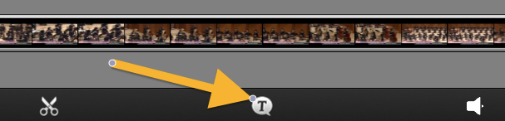

To create a new text bubble box, tap the timeline.

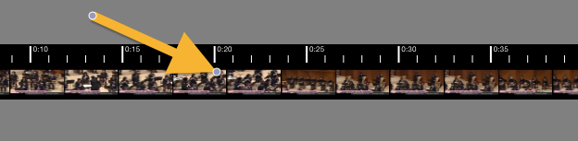

To add or edit text, tap the bubble box you want. When it's highlighted, DOUBLE TAP the subtitle area and then enter the text you want.

