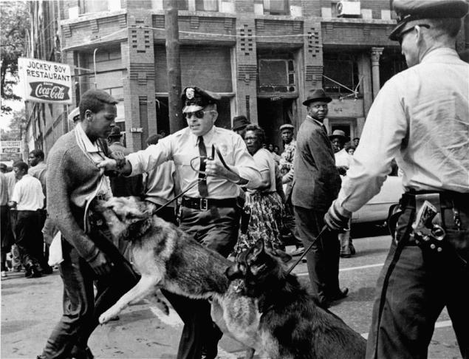
Protest observer, Walter Gadsden being attacked by police dogs during a Civil Rights protest, Birmingham, Alabama

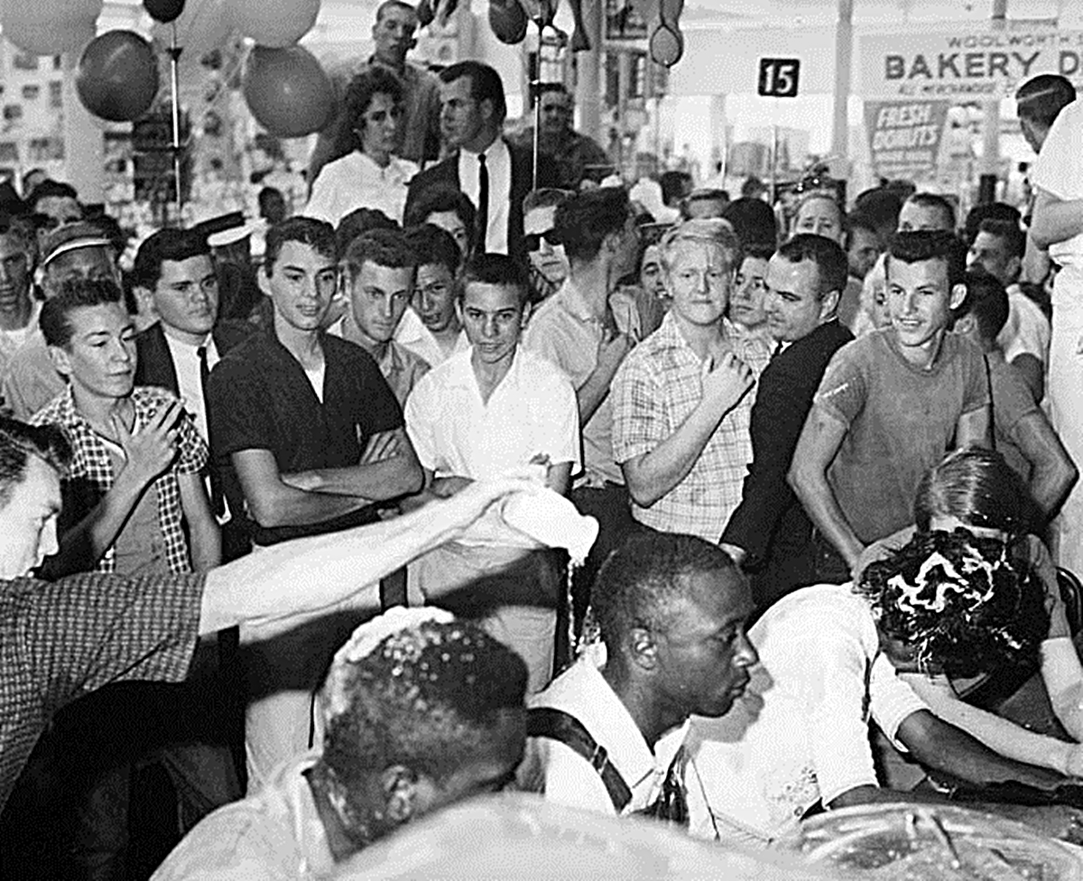
Fifty years ago, an angry white mob attacked a racially mixed group that sought to integrate a whites-only lunch counter in Mississippi's capital city.

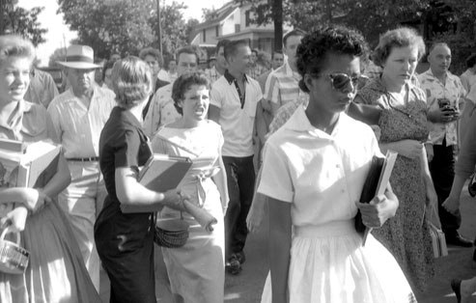
Elizabeth Eckford, followed and taunted by an angry crowd after she was denied entrance to Little Rock Central High School, September 4, 1957. T

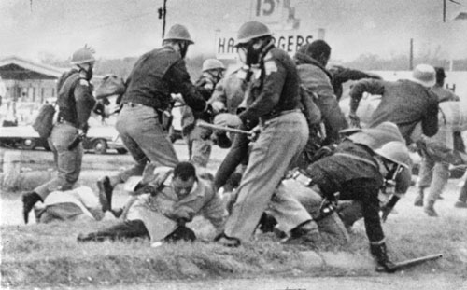

John Lewis, the leader of Student Nonviolent Coordinating Committee, is beaten by a state trooper March 7, 1965, as he attempts to march with 600 others from Selma to Montgomery, Alabama, in a right-to-vote demonstration. Many marchers suffered broken bones and temporary blindness by tear gas.

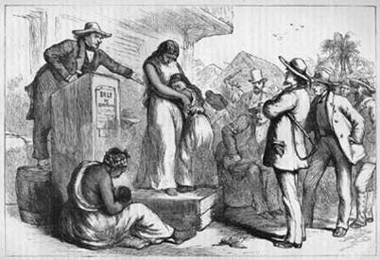

Auction Block was used to buy and sell many items including the buying and selling of slaves.

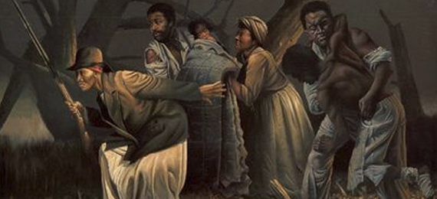

The Underground Railroad, a vast network of people who helped fugitive slaves escape to the North and to Canada, was not run by any single organization or person. Rather, it consisted of many individuals -- many whites but predominantly black . The Underground Railroad had many notable participants, including Harriet Tubman, who made 19 trips into the South and escorted over 300 slaves to freedom.

