Sample Visual Arts Assessment

Student Booklet
Proctor Booklet
Scoring Rubrics

Fall 2013

NOTE FROM ARTS ACHIEVE

This performance assessment was developed by staff from Studio in a School in conjunction with the New York City Department of Education’s Visual Arts Coordinator. This packet contains the student assessment booklet, proctor booklet, and rubrics used to score each task.

The Arts Achieve assessments were developed for the specific purpose of measuring students’ overall achievement as a class. Results will reveal gaps in student learning and provide insight into how students can progress toward recognized standards. In this way, the assessment results can also be used to measure teacher effectiveness. It is NOT the intention for this assessment to be used to grade individual students.

In the Visual Arts assessment, students demonstrate their knowledge of art, both in writing and by making artworks in various media. Reproductions of visual artworks serve as prompts throughout. The assessment process includes a partnered discussion.

Discipline-Based Performance Tasks
- Students draw various kinds of lines and textures to demonstrate understanding of the concepts.
- They create a work of art in a given medium (e.g., drawing, collage, painting) within set parameters, following clear instructions.

Written Performance Tasks
- Differentiate types of lines, textures, colors, tints, shades, shapes, values, and forms.
- Explain how elements of art and principles of design create an effect.
- Decode an exhibition label.
- Recognize periods of art.
- Interpret a work of art and write about artistic process.

The Visual Arts assessments utilize a wide variety of masterworks; historical, contemporary, and student-generated. Arts Achieve obtained the rights to use museum artwork in several of the tasks, but we are unable to distribute them in this packet. We have inserted notes on our masterwork selection throughout the assessment. Though we are unable to share many of the pieces, these or comparable works can be found using other resources. For tasks that utilized student work, we have included the same pieces that were used in the original assessment.

While all of the Arts Achieve performance assessments are psychometrically validated and developed against recognized standards, instructors are encouraged to re-interpret and modify tasks to fit their own classes’ needs. We hope this assessment will be useful to your practice and your students!

PART I
1. Artists pay attention to details. Here is a carefully observed drawing of a sleeping lion by
Rembrandt van Rijn. Look at it closely and notice how Rembrandt:

Observed and drew the shapes made by the lion’s body and skin
Showed the texture of the lion’s skin and mane
Used light and shadow to show three-dimensionality

NOTE FROM ARTS ACHIEVE: The piece for this task must make clear use of light and shadow. It was important to use work of a noted artist as one goal of the assessment is to introduce students to masterworks. We selected a drawing of a sleeping lion by Rembrandt.

Now, you have the opportunity to demonstrate how carefully you can observe and draw an object, show its details, shape and texture, and use light and shadow. Remember to:

• Carefully observe the object in front of you, a seashell

• Draw your shell large enough to fill the entire page

• Draw the shapes that make up the seashell

• Look closely and draw the details

• Give the seashell texture

• Use light and shadow in your drawing to show three-dimensionality
2. Rembrandt also carefully observed people. So did two secondary students whose work is below. Artists create
people in different ways. The way these two artists painted people tells us something about who the people are. Compare and contrast these two paintings by answering questions about each one.
 | 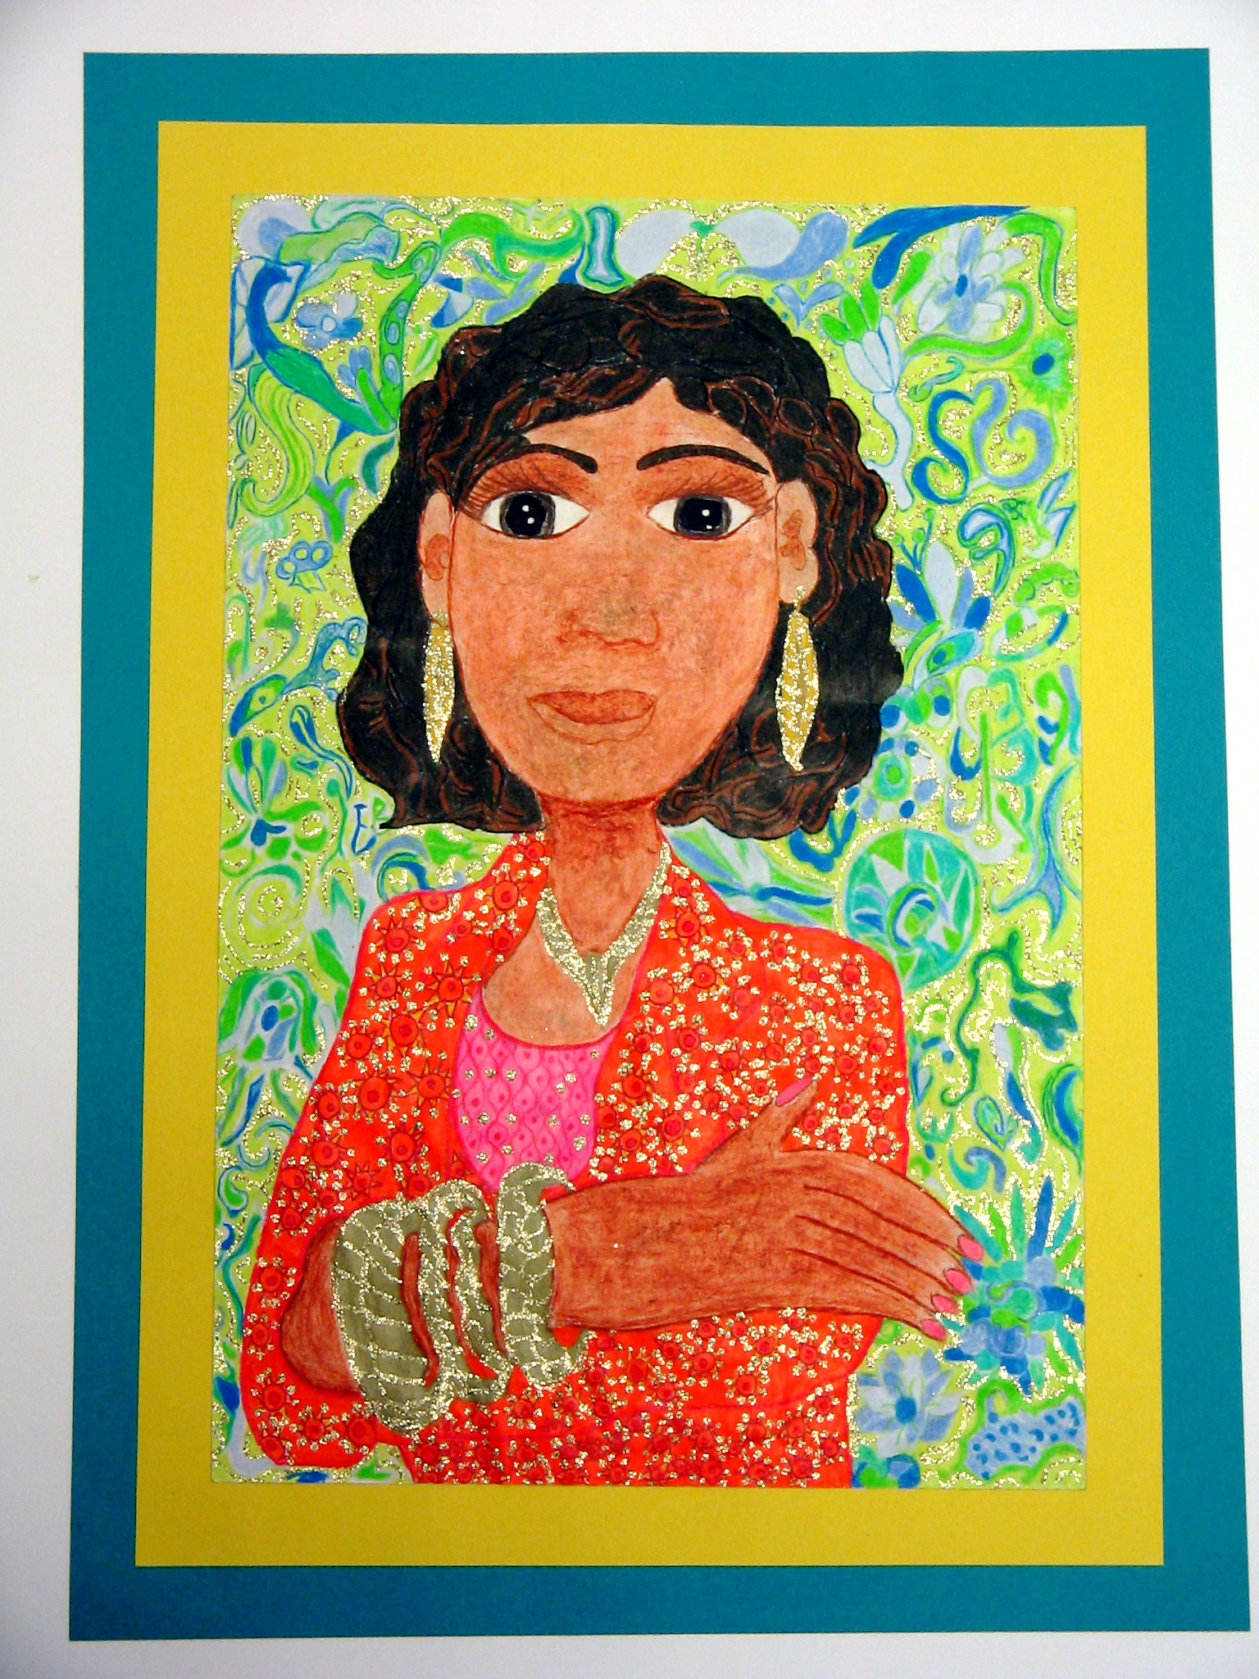 | 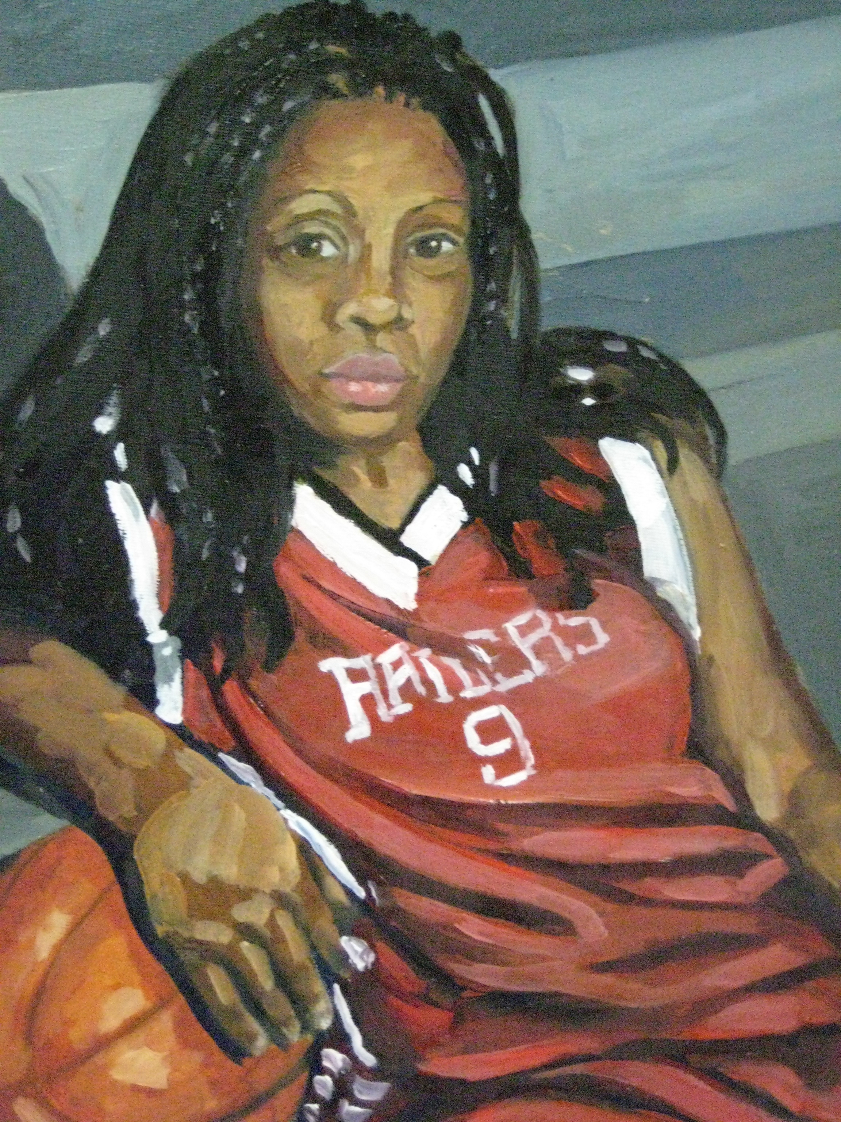
What do you think each artist wants us to know about the person she painted?

Why did each artist choose these specific colors for her painting?

What is the mood of each portrait?

How does the background of each portrait add to the painting?

GO ON TO PAGE 5

3. Both artists on page 4 mixed and used many colors to achieve variety in their artwork.
Look at it this color wheel and fill in the spaces below.
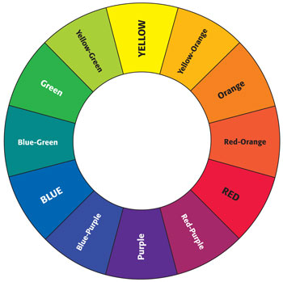

The three primary colors are:

_______________________ _____________________ ____________________

The three secondary colors are:

_______________________ _____________________ ____________________

Two complementary colors in this color wheel are:

_______________________ _____________________

Three analogous colors in this color wheel are:

_______________________ _____________________ ____________________

GO ON TO PAGE 6
Artists express themselves in many media. Teodelapio, a stabile by Alexander Calder, is made of sheet metal.

NOTE FROM ARTS ACHIEVE: The sculpture image for Tasks 4 and 5 should be clear enough for students to answer items about negative/positive space, symmetrical/asymmetrical balance, organic/geometric shapes, abstract/realistic. We selected Teodelapio by Alexander Calder (1962).

Refer to Teodelapio to complete items 4 and 5.

4. In the picture of the sculpture, place an X on one area of negative space.

5. Circle either A or B for each item below:

• The balance in this artwork is:

A. symmetrical B. asymmetrical

• The shapes made by the steel pieces are best described as:

A. organic B. geometric

• This artwork may best be described as:

A. abstract B. realistic

GO ON TO PAGE 7

6. You are a museum educator writing a guidebook for 8th grade students. You have selected these
4 works of art for your guidebook. You want to put them in chronological order from ancient to modern.

Number the images below from 1 to 4, with number 1 being the most ancient work of art.
Place the numbers on the lines below each work of art.

NOTE FROM ARTS ACHIEVE: This task met our desire to have students learn as they were assessed; not many middle schoolers have thought about the art history continuum. Images for this task used should clearly fall into 4 distinct categories. We used:
- Prehistoric Cave Painting: Two Bisons from Altamira, Spain
- Ancient Egyptian: Wall painting from Mer-ib's tomb (around 2400 BCE)
- 19th Century portrait: Henry Ossawa Tanner’s The Banjo Lesson (1893)
- 20th Century abstract painting: Frank Stella’s Shoubeegi (1978)

7. So far in this booklet you have looked at paintings, drawings and sculpture. In Part II you will be working
in another medium, collage. To prepare for this you will be looking at a collage by Romare Bearden
entitled String Band and you will discuss it with a partner.

Artists often use both observation and imagination when they create their work.

Questions to discuss with your partner:
• How did Bearden use his observations to help him create String Band?
• How did Bearden use his imagination to help him create String Band?

Use the Elements of Art in your discussion:

COLOR LINE SHAPE VALUE SPACE TEXTURE FORM

NOTE FROM ARTS ACHIEVE:
This task should feature a collage that encourages discussion of the use of color and shape to create unique compositions. We selected Romare Bearden’s String Band (1968). This is an ungraded task used for students’ paired discussion to set the stage for an art activity.

END OF PART I

PART II
PERFORMANCE TASK

8. Now it’s your turn to create a collage. Think of a garden, landscape, or an underwater scene.
Use memories of past observations, and use your imagination to come up with a scene for your collage.
Surprise the viewer with your creativity!

Remember:

Use any color for your base paper.

Use a variety of colors and shapes in an expressive way to create your scene.

You can tear the paper as well as cut the paper.

Before you glue, experiment with the placement of colors and shapes to create a unique collage.

Fill the entire page with your collage.

As you work, check the boxes below to make sure you are following the directions.

√
Am I creating a garden, landscape or underwater scene from
my memories of past observations, and my imagination?
Am I thinking carefully and expressively about the colors and shapes I am using?
Am I remembering that I can tear and cut paper if I wish to?
Am I experimenting with placement of colors and shapes to create a unique collage?
Am I filling the entire page with my collage?

9. Paintings often tell stories. Turn back to page 8 and look once again at String Band by
Romare Bearden.
• Describe what might be going on.
• What are some of the little details that you notice in the work?
• Can you predict what might happen next?
• What makes you say that?

NOTE FROM ARTS ACHIEVE: This piece should be a narrative with a topic that is engaging to middle school students. We selected George Bellows’s Cliff Dwellers (1913).

10. Paintings that tell stories are called narrative paintings.
Look at your own large reproduction of the narrative
painting on this page. It is by George Bellows and it’s
entitled Cliff Dwellers. You will have the opportunity
to write a story about part of this painting.

George Bellows painted Cliff Dwellers one hundred years ago. It is a scene of a street in New York City and if you look very carefully you can imagine many stories in this artwork.
Focus on one group of people that Bellows painted. Use your imagination and create a dramatic story about these people. Include details from the painting to make your story interesting.

In your story:

• For the setting of your story, include the background, color, and mood of the painting.

• Bring the characters to life as you develop your story about them.

• To end your story, predict what will happen next.

• Use evidence in the painting to support your prediction.

• Give your story a title.

Your story should have 2 or more paragraphs and be written in full sentences.
Remember to check your spelling and punctuation.

Title: _______________________________________________________________________________________________________________________________________________________________________________________________________________________________________________________________________________________________________________________________________________________________________________________________________________________________________________________________________________________________________________________________________________________________________________________________________________________________________________________________________________________________________________________________________________________________________________________________________________________________________________________________________________________________________________________________________________________________________________________________________________________________________________________________________________________________________________________________________________________________________________________________________________________________________________________________________________________________________________________________________________________________________________________________________________________________________________________________________________________________________________________________________________________________________________________________________________________________________________________________________________________________________________________________________________________________________________________________________________________________________________________________________________________________________________________________________________________________________________________________________________________________________________________________________________________________________________________________________________________________________________________________________________________________________________________________________________________________________________________________________________________________________________________________________________________________________________________________________________________________________________________________________________________________________________________________________________________________________________________________________________________________________________________________________________________________________________________________________________________________________________________________________________________________________________________________________________________________________________________________________________________________________________________________

END OF PART II

________________________________________________________________________________________________________________________________________________________________________________________________________________________________________________________________________________________________________________________________________________________________________________________________________________________________________________________________________________________________________________________________________________________________________________________________________________________________________________________________________________________________________________________________________________________________________________________________________________________________________________________________________________________________________________________________________________________________________________________________________________________________________________________________________________________________________________________________________________________________________________________________________________________________________________________________________________________________________________________________________________________________________________________________________________________________________________________________________________________________________________________________________________________________________________________________________________________________________________________________________________________________________________________________________________________________________________________________________________________________________________________________________________________________________________________________________________________________________________________________________________________________________________________________________________________________________________________________________________________________________________________________________________________________________________________________________________________________________________________________________________________________________________________________________________________________________________________________________________________________________________________________________________________________________________________________________________________________________________________________________________________________________________________________________________________________________________________________________________________________________________________________________________________________________________________________________________________________________________________________________________________________________________________________

END OF PART II

Arts Achieve
Middle School Visual Arts Assessment
2013
PROCTOR INSTRUCTIONS

Name _____________________________________ OSIS # __________________
Class _____________________________________
School _____________________________________
Date _____________________________________

SAY: Today you will have the chance to demonstrate what you have learned in your art classes. You will be answering questions, and using drawing pencils and collage materials. All the materials that you will need will be provided.

Assessment booklets will now be given out.

Please use your #2 pencils to fill in the information on the front cover. OSIS #’s will be added later.
Put the #2 pencils away. Read A Note to the Student silently as I read it aloud.

A Note to the Student:
As middle school students you have had the opportunity to learn many skills in the art studio. You also
have gained understandings about the process of making art . You will find the activities in this booklet
are engaging and will give you a chance to demonstrate the skills and the understandings you have acquired
in elementary school and middle school. For each activity read the directions carefully.

Distribute a packet of papers to each student.

SAY: Please do not open the packet until I tell you to. Your packet contains drawing paper and collage papers. You will be using the drawing paper first and the collage papers later on.

Distribute drawing pencils, sharpeners and gum erasers. Students should understand that the gum
eraser is an art tool and is not provided just to erase what students may perceive as errors. It should be used to create highlights and shading.

Open your booklet and fold it back so you are looking only at page 3. Read along silently as I review the instructions for the first activity.

NOTE: All art images in this document with the exception of student work are provided through
ARTstor with its permission.

PART I

1. Artists pay attention to details. Here is a carefully observed drawing of a sleeping lion by
Rembrandt van Rijn. Look at it closely and notice how Rembrandt:

Observed and drew the shapes made by the lion’s body and skin
Showed the texture of the lion’s skin and mane
Used light and shadow to show three-dimensionality
NOTE FROM ARTS ACHIEVE: The piece for this task must make clear use of light and shadow. It was important to use work of a noted artist as one goal of the assessment is to introduce students to masterworks. We selected a drawing of a sleeping lion by Rembrandt.

Now, you have the opportunity to demonstrate how carefully you can observe and draw an
object, show its details, shape and texture, and use light and shadow. Remember to:

• Carefully observe the object in front of you, a seashell

• Draw your shell large enough to fill the entire page

• Draw the shapes that make up the shell

• Look closely and draw the details

• Give the seashell texture

• Use light and shadow in your drawing to show three-dimensionality

SAY: You have 15 minutes to complete your drawing. I’ll tell you when 5 minutes are left.
You may begin.

When time is up:

SAY: Please write your first and last name on the back of your drawing and put it aside. Put the drawing
pencil and gum eraser aside for collection and take out your #2 pencil. Turn to page 4.

SAY: Next you will complete pages 4, 5, 6 and 7. Let’s look at these pages together now to review what you will be doing on your own. You will look carefully at the two works of art on page 4 and will complete the chart below the images. When you have finished you will go on to pages 5, 6 and 7. Let’s look at those pages next.

Read only the blue colored text. Students are not to begin work until you have read the directions for
these items. Reassure them that they will have plenty of time and should not begin until you tell them to.
Note that the stop sign on page 7 means do not go on.

These 4 pages should take the students 20 minutes. You may allow an extra 5 minutes if needed.

2. Rembrandt also carefully observed people. So did two secondary students whose work is below. Artists create
people in different ways. The way these two artists painted people tells us something about who the
people are. Compare and contrast these two paintings by answering questions about each one.

What do you think the artist wants us to know about each subject?
Why did each artist choose these specific colors for her painting?
What is the mood of each portrait?

How does the background of each portrait add to the painting?

GO ON TO PAGE 5

3. Both artists on page 4 mixed and used many colors to achieve variety in their artwork.
Look at it this color wheel and fill in the spaces below.

The three primary colors are: ___________ __________ ___________

The three secondary colors are: ___________ __________ ___________

Two complementary colors in this color wheel are: ___________ __________

Three analogous colors in this color wheel are: _________ __________ ________

GO ON TO PAGE 6

Artists express themselves in many media. Teodelapio, a stabile by Alexander Calder, is made of sheet metal.
NOTE FROM ARTS ACHIEVE: The sculpture image for Tasks 4 and 5 should be clear enough for students to answer items about negative/positive space, symmetrical/asymmetrical balance, organic/geometric shapes, abstract/realistic. We selected Teodelapio by Alexander Calder (1962).

Refer to Teodelapio to complete items 4 and 5.

4. In the picture of the sculpture, place an X on one area of negative space.

5. Circle either A or B for each item below:

• The balance in this artwork is:

A. symmetrical B. asymmetrical

• The shapes made by the steel pieces are best described as:

A. organic B. geometric

• This artwork may best be described as:

A. abstract B. realistic

GO ON TO PAGE 7

6. You are a museum educator writing a guidebook for 8th grade students. You have selected these 4 works of art for your guidebook. You want to put them in chronological order from ancient to modern.

Number the images below from 1 to 4, with 1 being the most ancient work of art. Place the numbers on the lines below each work of art.

SAY: Now you may go back to page 4 and begin.

NOTE FROM ARTS ACHIEVE: This task met our desire to have students learn as they were assessed; not many middle schoolers have thought about the art history continuum. Images for this task used should clearly fall into 4 distinct categories. We used:
- Prehistoric Cave Painting: Two Bisons from Altamira, Spain
- Ancient Egyptian: Wall painting from Mer-ib's tomb (around 2400 BCE)
- 19th Century portrait: Henry Ossawa Tanner’s The Banjo Lesson (1893)
- 20th Century abstract painting: Frank Stella’s Shoubeegi (1978)

When time is up:

SAY: Please put #2 pencils away and turn to page 8. Read along silently as I read aloud.

#2 pencils are put away because students should not be using them as they do their collage work.

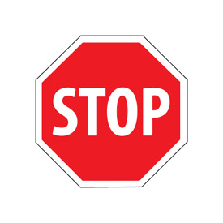

NOTE: This page of the assessment is not graded. Item 7 gives students the opportunity to speak to each other about a work of art. Give students 5 minutes for discussions. If they are very engaged in their conversations, you may give them an additional 5 minutes.

At the end of the discussions ask for volunteers to share their ideas. Make sure as students share
that they are focusing on Bearden using his observations as well as his imagination. Encourage
students to use some of the Elements of Art in their responses.

7. So far in this booklet you have looked at paintings, drawings and sculpture. In Part II you will be working
in another medium, collage. To prepare for this you will be looking at a collage by Romare Bearden
entitled String Band and you will discuss it with a partner.

Artists often use both observation and imagination when they create their work.

Questions to discuss with your partner:
• How did Bearden use his observations to help him create String Band?
• How did Bearden use his imagination to help him create String Band?

Use the Elements of Art in your discussion:

COLOR LINE SHAPE VALUE SPACE TEXTURE FORM
NOTE FROM ARTS ACHIEVE:
This task should feature a collage that encourages discussion of the use of color and shape to create unique compositions. We selected Romare Bearden’s String Band (1968). This is an ungraded task used for students’ paired discussion to set the stage for an art activity.

SAY: Part I is over. Close your booklets. Keep your drawing, and put all other materials in your
plastic packets. Take 5 minutes to stand and stretch. Then we will continue with Part II.

END OF PART I

SAY: Turn to page 9, Part II of the assessment. Fold the booklet back so you have just page 9 in front of you. It says PART II PERFORMANCE TASK on top of the page. Read along silently.

PART II

PERFORMANCE TASK
8. Now it’s your turn to create a collage. Think of a garden, landscape, or an underwater scene.
Use memories of past observations, and use your imagination to come up with a scene for your collage.
Surprise the viewer with your creativity!

Remember:
Use any color for your base paper.
Use a variety of colors and shapes in an expressive way to create your scene.
You can tear the paper as well as cut the paper.
Before you glue, experiment with the placement of colors and shapes to create a unique collage.
Fill the entire page with your collage.

As you work, check the boxes below to make sure you are following the directions.
√
Am I creating a garden, landscape or underwater scene from
my memories of past observations, and my imagination?
Am I thinking carefully and expressively about the colors and shapes I am using?
Am I remembering that I can tear and cut paper if I wish to?
Am I experimenting with placement of colors and shapes to create a unique collage?
Am I filling the entire page with my collage?

Ask students to take out the collage packet and set it aside. NOTE: Scissors are to be supplied by the school and should be given out now. Remind students that #2 pencils should be put away.

SAY: You will have 35 minutes to work on your collage. I’ll tell you when 5 minutes are left.

When time is up:
SAY: Please put your name on the back of your collage and set it aside. Leave scissors and glue sticks out for collection. Put the other materials into the packet. Turn to page 10.

As a way of scaffolding instruction, before the students write about the Bellows painting, they will return to the collage by Romare Bearden. Invite students to look closely at the Bearden work and respond to the four prompts. Call on several students for their responses. Allow 5 minutes for this.

9. Paintings often tell stories. Turn back to page 8 and look once again at String Band by
Romare Bearden.
• Describe what might be going on.
• What are some of the little details that you notice in the work?
• Can you predict what might happen next?
• What makes you say that?
NOTE FROM ARTS ACHIEVE: This piece should be a narrative with a topic that is engaging to middle school students. We selected George Bellows’s Cliff Dwellers (1913).
After looking at the Bearden, read aloud to students:

10. Paintings that tell stories are called narrative paintings.
Look at your own large reproduction of the narrative
painting on this page. It is by George Bellows and it’s
entitled Cliff Dwellers. You will have the opportunity
to write a story about part of this painting.

George Bellows painted Cliff Dwellers one hundred years ago. It is a scene of a street in
New York City and if you look very carefully you can imagine many stories in this artwork.

Focus on one group of people that Bellows painted. Use your imagination and create a dramatic
story about these people. Include details from the painting to make your story interesting.

In your story:

• For the setting of your story, include the background, color, and mood of the painting.
• Bring the characters to life as you develop your story about them.
• To end your story, predict what will happen next.
• Use evidence in the painting to support your prediction.
• Give your story a title.

Your story should have 2 or more paragraphs and be written in full sentences.
Remember to check your spelling and punctuation.

SAY: You will have 20 minutes to write your story and I will tell you when 5 minutes are left.
Remind students to look at these instructions as they write their stories. They do not have to fill the entire two pages, but should be encouraged to write at length.

Title: ___________________________________________________________________________________________________________________________________________________________________________________________________________________________________________________________________________________________________________________________________________________________________________________________________________________________________________________________________________________________________________________________________________________________________________________________________________________________________________________________________________________________________________________________________________________________________________________________________________________________________________________________________________________________________________________________________________________________________________________________________________________________________________________________________________________________________________________________________________________________________________________________________________________________________________________________________________________________________________________________________________________________________________________________________________________________________________________________________________________________________________________________________________________________________________________________________________________________________________________________________________________________________________________________________________________________________________________________________________________________________________________________________________________________________________________________________________________________________________________________________________________________________________________________________________________________________________________________________________________________________________________________________________________________________________________________________________________________________________________________________________________________________________________________________________________________________________________________________________________________________________________________________________________________________________________________________________________________________________________________________________________________________________________________________________________________________________________________________________________________________________________________________________________________________________________________________________________________________________________________________________________________________________________________________________________

END OF PART II

__________________________________________________________________________________________________________________________________________________________________________________________________________________________________________________________________________________________________________________________________________________________________________________________________________________________________________________________________________________________________________________________________________________________________________________________________________________________________________________________________________________________________________________________________________________________________________________________________________________________________________________________________________________________________________________________________________________________________________________________________________________________________________________________________________________________________________________________________________________________________________________________________________________________________________________________________________________________________________________________________________________________________________________________________________________________________________________________________________________________________________________________________________________________________________________________________________________________________________________________________________________________________________________________________________________________________________________________________________________________________________________________________________________________________________________________________________________________________________________________________________________________________________________________________________________________________________________________________________________________________________________________________________________________________________________________________________________________________________________________________________________________________________________________________________________________________________________________________________________________________________________________________________________________________________________________________________________________________________________________________________________________________________________________________________________________________________________________________________________________________________________________________________________________________________________________________________________________________

END OF PART II

SAY: Session II is over. Please make sure that you have written your first and last name on the
back of your drawing and collage. Make sure the drawing and the collage are in your booklet.
Place all other art materials back in the packet. Materials and booklets with the artwork inside will now be collected.

Thank students for all of the wonderful work they have done in both sessions!

END OF PART II
i-3 ARTS ACHIEVE VISUAL ARTS 8th Gr. RUBRIC Fall 2013 Year 3 of Implementation NOTE: SHORT ANSWERS AND UNGRADED ITEM ARE SHADED
TASK | Exceeds Performance Indicators* | Meets Performance Indicators* | Nears Performance Indicators * | Falls Short of Meeting the Performance Indicators*
1.Drawing an object from observation I,K,A,E  *Although performance assessment says, “Fill the whole page appropriately,” points should not be taken off if adjudicator can see the details. | 1.Composition: fills the page appropriately, drawing shell large enough to view details clearly*  2. Employs a range of strategies (e.g. stippling, cross-hatching, smudging) to carefully observe and skillfully render, showing shape of shell  3.Appropriately indicates the light and shadow on shell to show 3-dimensionality  4. Drawing has highly detailed, fully-realized quality (e.g., includes ridges, edges, variations in value on surface, texture)  5.Student makes successful creative choices and exercises imaginative capacities in the drawing | 1. Composition: fills the page appropriately, drawing shell large enough to view some, but not all of the details clearly *  2. Employs strategies to observe and render shape of shell  3. Shows light and shadow on the shell to show 3-dimensionality.  4. Drawing is somewhat detailed, but may not contain fully fleshed out details; may be more of a sketch than have a fully-realized quality (e.g., shows some ridges, edges, variations in value on surface and/or some texture)  5. Student makes creative choices and uses imaginative capacities in the drawing, but is not fully successful | 1. Composition: Does not compose large enough to fill the page appropriately, making it difficult for viewer to see details, but attempts to draw at least the outline of the shell*  2.The shape of the shell is not carefully observed or skillfully rendered  3. May show light or shadow, but not both or not both appropriately, to show 3-dimensionality.  4. Drawing is not detailed, although the student attempts to employ at least one of the strategies (e.g., tries to give the shell one of the following: some surface quality or some texture)  5. Student makes little attempt to make creative choices and/or use imaginative capacities in the drawing | 1. Composition: Does not fill the page appropriately*.  2. The student does not draw the shape of the shell successfully  3. Does not show light or shadow on shell to show 3-dimensionality.  4. Shell retains two-dimensional appearance, or not fully recognizable as a shell  5. Student does not make creative choices or use imaginative capacities in the drawing

2 A and 2B: Portraits  I,K,A,C,E  For each of the 2 portraits, the overall descriptions to the right will help guide you. However, each portrait will be graded on each of the 4 specific concepts separately from 1-4. This is a change from the original rubric. | Responds in detail to each of the questions/ descriptive responses for each of the portraits using appropriate art vocabulary in context. Ideas demonstrate a high degree of understanding of what the artists were trying to accomplish, using descriptive and expressive language in the short answers. May go above and beyond in each description Goes into this level of commentary in all of the answers. Uses art vocabulary in all or most of answers. | Responds to each of the questions/descriptive responses for each of the portraits, but may not always use appropriate art vocabulary in context.. Ideas demonstrate understanding of what the artists were trying to accomplish, but may not use fully descriptive and expressive language that helps reader understand student’s interpretation; able to respond to each question but only in short answers, e.g., states a fact like “the mood is dark,” but not how the background adds to that mood and the painting overall. | Does not respond to all of the questions/descriptions, or responses do not use appropriate art vocabulary in context, but student attempts to provide some answers. The answers may not be appropriate to what the student is asked in the question. Ideas demonstrate some understanding of what the artists were trying to accomplish, and student attempts some responses, though with little detail. | Some answers are missing. Answers do not use appropriate art vocabulary, do not relate to the question or description or are incorrect. e.g., may not correctly define what “mood” is or describe how the background adds to the painting.  Any ideas presented are not clearly communicated or do not contain details that shows that student understands concepts.
PORTRAIT 2A (Left) | Artist’s Intent
 | Color
 | Mood
 | Background
PORTRAIT 2B (Right) | Artist’s Intent
 | Color
 | Mood
 | Background

3.Color wheel  recognizing and identifying types of colors K | Task 3 A-D:  Number of Colors Correctly Identified
A. Primary Colors  (0-3) | ________
B. Secondary Colors  (0-3) | _______
C. Complementary Colors  (0-2) | _______
D. Analogous Colors  (0-2) | _______
4.Teodelapio: defining negative space  K | Xxxxxxxxxxxxxxxxxxxxxxxxxxx | Correctly places an x on an one area of negative space | Xxxxxxxxxxxxxxxxxxxxxxxxxxxxxxxxxxxx | Does not correctly place an x on one area of negative space
5A. Teodelapio: electing correct response about balance; K | Xxxxxxxxxxxxxxxxxxxxxxxxxx | Correctly identifies art as example of asymmetrical balance | Xxxxxxxxxxxxxxxxxxxxxxxxxxxxxxxxxxxx | Incorrectly identifies art as example of symmetrical balance
5B. Teodelapio: selecting correct response about shape; K | Xxxxxxxxxxxxxxxxxxxxxxxxx | Correctly identifies largest part of art as organic | Xxxxxxxxxxxxxxxxxxxxxxxxxxxxxxxxxxxx | Incorrectly identifies largest part of art as geometric
5C. Teodelapio: selecting correct response about type of art; K | Xxxxxxxxxxxxxxxxxxxxxxxxxx | Correctly identifies art as abstract | Xxxxxxxxxxxxxxxxxxxxxxxxxxxxxxxxxxxx | Incorrectly identifies art as realistic
6.Timeline  K,E,U | Xxxxxxxxxxxxxxxxxxxxxxxxxx | Able to place all of the artworks in correct chronological order | Xxxxxxxxxxxxxxxxxxxxxxxxxxxxxxxxxxxx | Does not place the artworks in correct chronological order
7. Bearden Collage | Task not scored

8. PERFORMANCE TASK I: Making a collage of a garden, landscape or underwater scene I,K,A | - Composition: fills the page appropriately so scene is readable.  - Demonstrates ability to carefully choose colors for deliberate effect in creating composition. Collage achieves a highly expressive quality, e.g., setting has a very unique sense of detail, place and/ or mood through placement of colors and shapes, e.g., stormy, jungle-like  - Demonstrates ability to carefully place shapes for deliberate effect in creating an expressive composition, e.g., considers all areas of base paper when placing shapes; limits shapes so composition is very clear and focused.  - Great facility is shown in cutting and/or tearing shapes (shapes have clean edges or edges are deliberately textured)  - xxxxxxxxxxxxxxxxxxx | - Composition: fills most of the page; most of scene is readable.  - Demonstrates ability to choose colors, and most colors are chosen with deliberate effect in creating composition. Collage achieves an expressive quality and a sense of uniqueness through placement of colors and shapes.  - Demonstrates ability to place shapes for effect in creating an expressive composition, e.g., most areas of base paper are considered when placing shapes.  - Facility is shown in cutting and/or tearing shapes but shapes may not all have clean edges; may not use the scissor imaginatively to texture edges of paper to depict details  - Great facility is shown with gluing (glue does not show on face of collage; shapes are glued completely down). | 1.Composition: does not compose clearly or large enough to fill the page appropriately; difficult for the viewer to read the scene.  2. Demonstrates little ability to choose colors, but the choices reflect at least a rudimentary understanding of using them in creating a composition. Collage is not fully expressive, but attempts to show enough details through placement of colors and shapes to complete a sense of place, though not necessarily unique.  3. Demonstrates little ability to place shapes for effect in creating an expressive composition, but attempts in a rudimentary way to place some shapes.  4. Little facility is shown in cutting and/or tearing shapes (may have some difficulty handling scissors with dexterity as a drawing tool (shapes may not have clean edges, shapes depicted may be rudimentary and lacking in detail, e.g., circles for tree-tops)  5. Facility is shown with gluing, but some glue may show on the face of the collage or shapes may not be clompletely glued down. | - Composition: Does not fill the page appropriately. Does not compose a recognizable scene.  - Demonstrates no ability to use varied color to create a composition. Collage is not expressive and does not achieve enough detail to create a sense of place through placement of colors and shapes.  - Demonstrates no ability to place shapes for effect in creating an expressive composition.  - No facility is shown in cutting and/or tearing papar to effectively create collage  - Does not have adequate facility with gluing, but attempts to glue down shapes.
9. WRITING (ELA)
Separate Rubric PERFORMANCE TASK II: Reflecting on collage I,K,A,C
COMMON CORE ATTRIBUTES
I demonstrate independence T technology C comprehend and critique E value evidence
K build strong content knowledge U understand perspectives and cultures
A demands of audience, task purpose and discipline

